Computer Modelling 2

Practical #7

**Question 1:**

What if we don’t want to use the Ball class? Or any externally created object? We can use the JavaScript Drawing API instead.

**Question 2:**

In Question 1, you have written a script that uses the JavaScript Drawing API to animate the Sine wave. See Figure 1.

*f*(*t*) = *sin*(*t*): This function has an amplitude (or range) of 1 because the graph goes one unit up and one unit down from the midline of the graph. This function has a period of 2π because the sine wave repeats every 2π seconds (intervals). The graph looks like this:

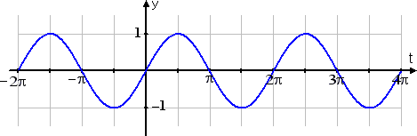

Figure 1

Now write a new script based on this original script. Three Sine wave animations should be displayed as follows:

1. The original Sine wave. See Figure 1.
2. The Sine wave stretched horizontally (by a factor of 2). See Figure 2.



Figure 2

1. The Sine wave compressed horizontally (by a factor of 2). See Figure 3.

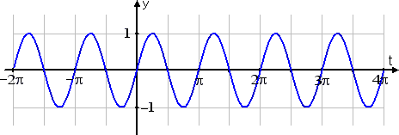

Figure 3

Note that each curve should have a distinct colour.

**Question 3:**

Note: you can use the Ball object for this question.

Write a script which animates two sine curves each with two different angle incrementations (or speeds) and centres. It then applies one of the angles to the ball’s x position, and the other to the ball’s y position.

If you use the following values, the effect is similar to a bug flying around a room.

xspeed = 0.07, yspeed = 0.11

centreX = canvasWidth/2, centreY = canvasHeight/2

**Range versus translation examples:**

**Example 1:**

*g*(*t*) = 3*sin*(*t*): This curve in Figure 4 has a range (or amplitude) of 3, and a period of 2π.

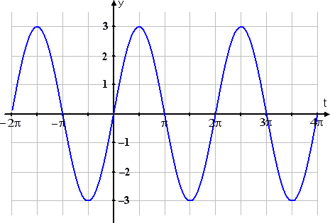

Figure 4

**Example 2:**

*k*(*t*) = *sin*(*t*) + 3: The curve in Figure 5 has a range of 1, a period of 2π, and is shifted up on the y axis by 3 units.

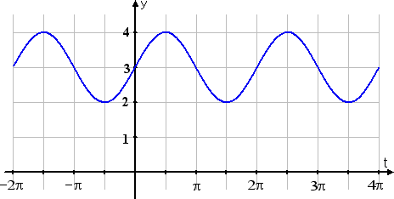

Figure 5

**Example output:**

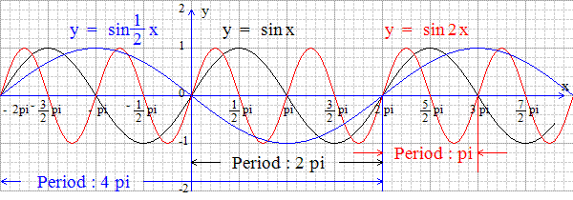

Figure 6

**Note on Figure 6:**

The red curve is cycling twice as fast so its period is only half as long.

The blue curve is cycling half as fast, so its period is twice as long.